
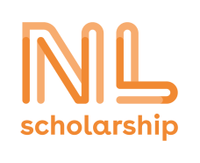
NL Scholarship Programme
Application form for incoming Bachelor students 2026/2027

Personal details
Family name :
Given name :
Date of birth :
Nationality :
Postal address :
Zip code and town :
Country :
E-mail address :
Telephone/mobile number :

Breda University of applied sciences
Your Buas student number :
Buas Bachelor programme :

Please e-mail the following to scholarships@buas.nl
□ this application form
□ your motivation letter for the NL Scholarship Programme! (There is no specific format for this letter; length ca 1 A4)
□ a copy of your Breda University of Applied Sciences (conditional) admission letter
□ proof of (excellent) English language proficiency (e.g. IELTS, TOEFL, Cambridge)

I herewith apply for the NL Scholarship and declare that I have completed this form to the best of my knowledge.

Date :
Place :
Signature:

